Student
Summer Employment
Biological Technician – Plants
Sierra Nevada – Eldorado NF
DUTIES INCLUDE:
- Field surveys for sensitive plants and noxious weeds (surveying requires off-trail hiking and driving on dirt roads)
- Native plant seed collection
- Assistance with restoration projects

SALARY:
- 13.53 – 18.75 per hour, dependent on education and experience

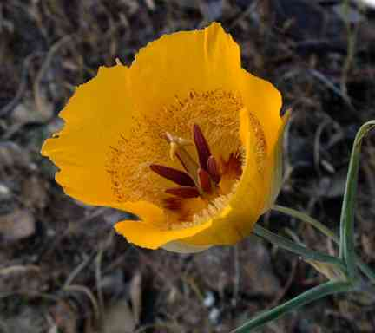
Calochortus clavatus var. avius

LOCATION: Eldorado National Forest, Supervisor’s Office, Placerville, CA
AVAILABILITY: May - August – Start and end dates negotiable with school schedules
STUDENT QUALIFICATIONS:
- At least 18 years of age with a current valid driver’s license
- Enrolled in or accepted to (with intent to attend) an accredited college or university, graduate or professional school in the fall; at least a half-time course load; proof of fall enrollment required prior to job offer
- Physically able to perform the job; a high degree of physical fitness is required
- United States citizen or national (resident of American Samoa or Swain Island)
- Courses in Botany, Natural Resources, Range Science, Biology, Conservation or other related fields preferred; Plant Taxonomy & Advanced Plant Tax recommended
APPLICATION: Submit your resume and transcripts by March 14, 2008 to:
Susan Durham
Eldorado National Forest OR sdurham@fs.fed.us
100 Forni Rd subject line: Summer employment
Placerville, CA 95667
QUESTIONS? Contact Susan Durham at sdurham@fs.fed.us or (530) 642-5173

